
PT 1 - EXAMINATION -23-24
ANSWER KEY
Subject: Accountancy  Grade: XII |  |  |  | Max. Marks: 35  Time:1 Hr. 15 minutes
Name: |  |  |  | Section: | Roll No:
General Instructions:
- All answers to be written on the answer sheet provided.
- Journal entries should accompany narrations.
- Working notes should be done.
 | A and B are partner’s sharing profit equally. A draw regularly Rs. 4,000 at the end of every month for 6 months. Year ended on 30thSeptember 2018, calculate interest on drawings @ rate 5% p.a. |  |  |  |  | (1)
 | A | 350 | B | 450
 | C | 150 | D | 250
 | ANSWER: D
2. | A partnership firm earned divisible profit of Rs. 5,00,000, interest on capital is to be provided to partner is Rs. 3,00,000, interest on loan taken from partner is Rs. 50,000 and profit-sharing ratio of partners is 5:3 sequence the following in correct way.  I. Distribute profits between partners.  - Charge interest on loan to Profit and Loss A/c  - Calculate the net profit Transfer to Profit and Loss appropriation A/c  - Provide interest on capital. |  |  |  |  | (1)
 | A | II, III, IV, I | B | II, III, I, IV
 | C | I, III, IV, I | D | III, II, I,IV
 | ANSWER - A
3. | Rani and Shyam are partners in a firm. They are entitled to interest on their capital, but the net profit was not sufficient for paying his interest, then the net profit will be disturbed among partner in |  |  |  |  | (1)
 | A | 1: 2 | B | Profit Sharing Ratio
 | C | Capital Ratio | D | Equally
 | ANSWER- C
4. | When interest on capital is paid whether there is profit or loss it is known as ----------------- |  |  |  |  | (1)
 | A | Charge against profit | B | Appropriation of profit
 | C | None of these | D | Both a and b
 | ANSWER - A
5. | Assertion (A): - Commission provided to partner is shown in Profit and Loss A/c.  Reason (R): - Commission provided to partner is charge against profits and is to be provided at fixed rate. |  |  |  |  | (1)
 | A | A) is correct but (R) is wrong | B | Both (A) and (R) are correct, but (R) is not the correct explanation of (A)
 | C | Both (A) and (R) are incorrect. | D | Both (A) and (R) are correct, and (R) is the correct explanation of (A)
 | ANSWER - C
6. | Gani, a partner withdrew ₹ 5,000 in the beginning of each quarter and interest on drawings was calculated as ₹ 1,500 at the end of accounting year 31 March 2022. What is the rate of interest on drawings charged? |  |  |  |  | (1)
 | A | 6% p.a. | B | 8% p.a.
 | C | 10% p.a. | D | 12% p.a.
 | ANSWER - D
7. | Shyam, Gopal & Arjun are partners carrying on garment business. Shyam withdrew ₹ 10,000 in the beginning of each quarter. Gopal withdrew garments amounting to ₹ 15,000 to distribute it to flood victims, and Arjun withdrew ₹ 20,000 from his capital account. The partnership deed provides for interest on drawings @ 10% p.a. The interest on drawing charged from Shyam, Gopal & Arjun at the end of the year will be.  SOLUTION:  Shyam - ₹ 2,500; Gopal- ₹ 750; Arjun- Nil. |  |  |  |  | 3
8. | Ajay, Manish, and Sachin were partners sharing profits in the ratio 5:3:2. Their Capitals were ₹ 6,00,000; ₹ 8,00,000 and ₹ 11,00,000 as on April 01, 2021. As per the Partnership deed, Interest on Capitals were to be provided @ 10% p.a. For the year ended March 31, 2022, Profits of ₹ 2,00,000 were distributed without providing for Interest on Capitals.  Pass an adjustment entry and show the workings clearly.  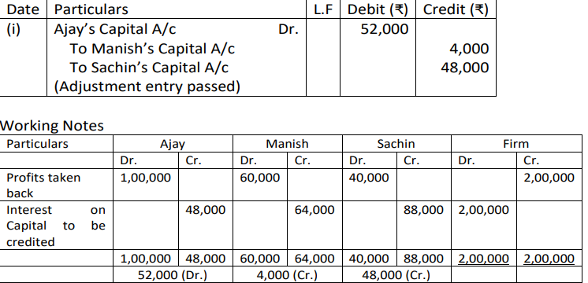 |  |  |  |  | 3
9. | Amay, Anmol and Rohan entered into partnership on 1st July 2021 to share profits and losses in the ratio of 3:2:1. Amay guaranteed that Rohan’s share of profit after charging interest on capital @ 6% p.a. would not be less than ₹ 36,000 p.a. Their fixed capital balances are: ₹ 2,00,000, ₹ 1,00,000, and ₹ 1,00,000 respectively. Profit for the year ended 31st March 2022 was ₹1,38,000.  Prepare Profit and Loss Appropriation A/c.  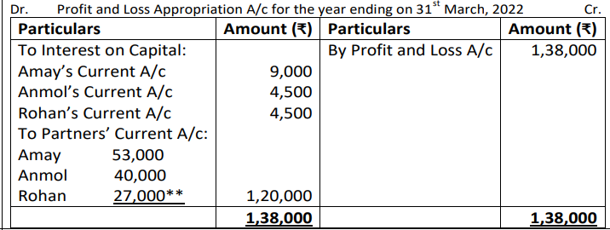 |  |  |  |  | 3
10. | P, Q and R were partners with fixed capital of ₹ 40,000, ₹32,000and ₹24,000. After distributing the profit of ₹48,000 for the year ended 31st March 2022 in their agreed ratio of 3: 1: 1. It was observed;  - Interest on capital was provided at 10% p.a. instead of 8% p.a.  - Salary of ₹ 12,000 was credited to P instead of Q.  You are required to pass a single journal entry in the beginning of the next year to rectify the above omissions.  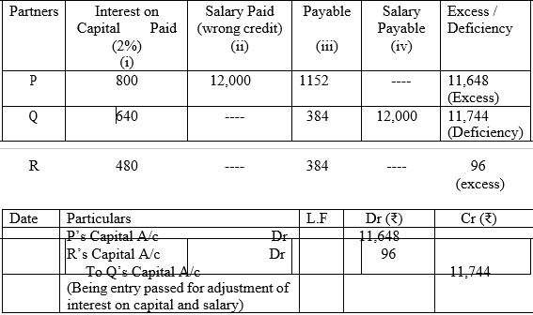 |  |  |  |  | 4
11. | Ajay, Binod and Chandra entered into partnership on 1st April 2019 with a capital of `3,00,000, `2,00,000 and `1,00,000 respectively. In addition to capital Chandra has advanced a loan of `1,00,000. Since they had no agreement to guide them, they faced the following issues during and at the end of the year.  - Ajay wanted interest on capital to be provided @8% p.a. but Binod and Chandra did not agree.  - Chandra wanted that interest on loan be paid to him @ 10% p.a., but Ajay and Binod wanted to pay @ 5% p.a.  - Ajay and Binod demanded to share profits in the ratio of their capital contribution, Chandra is not in agreement with this proposal.  - Binod, being our working partner, demands a lump sum payment of `40,000 as remuneration for which other partners are not in agreement.  You are required to suggest and help them resolve these issues.  SOLUTION:  - In the absence of the Partnership deed, the provisions of partnership act 1932 will apply according to which no interest on capital is payable.  - In the absence of partnership deed, the provisions of partnership act 1932 will apply according to which interest on loan by partner will be paid @6% pa.  - In the absence of partnership deed, the provisions of partnership act 1932 will apply according to which profits will be shared equally.  - In the absence of partnership deed, the provisions of partnership act 1932 will be applicable according to which no salary/remuneration is payable to any partner. |  |  |  |  | 4
12. | A, B and C are partners in a firm. Their respective capitals on 1st January 2011 were Rs. 2,00,000, Rs. 1,20,000 and Rs. 80,000.  The terms of partnership are as follows: –  i) Interest on capital is to be allowed @ 10% p.a.  ii) A and B are to get a monthly salary of Rs. 2,000 and Rs. 3,000 respectively.  iii) B is to be entitled to get a commission @ 10% after charging (i) and (ii).  iv) 10% of the divisible profit will be transferred to the Reserve.  v) Profit is to be shared up to 60,000 in their capital ratio and above that equally.  The profit for the year ended 31st December 2008 after charging A’s salary but before charging other provisions amounted to Rs. 1,76,000.  Prepare Profit and loss Appropriation Account.  PROFIT AND LOSS APPROPRIATION A/C |  |  |  |  | 6
  Particular | Rs. | Particular | Rs.
  To Interest on Capital |  | By Net Profit  (1,76,000+24,000) | 2,00,000
  A 20,000
  B 12,000
  C 8,000 | 40,000
  To Partner Salary
  A 24,000
  B 36,000 | 60,000
  To B's Commission  To Reserve | 10,000  9,000
  To Partners Capital (Profit)
  A 30,000+ 7,000
  B 18,000+ 7,000
  C 12,000+ 7,000 | 81,000
   | 2,00,000 |  | 2,00,000
13. | Neena and Sara were partners in a firm with fixed capitals of Rs. 5,00,000 and Rs. 4,00,000 respectively. It was discovered that interest on capital @ 6% p.a. was credited to the partners for the two years ending 31st March 2018 and 31st March 2019 whereas there was no such provision in the partnership deed. Their profit-sharing ratio during the last two years was:  2017-18; 4:5  2018-19; 5:1  Showing your workings clearly, pass the necessary adjustment entry to rectify the error.  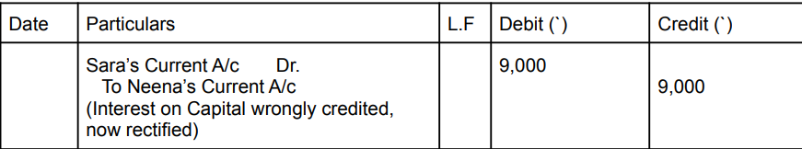 |  |  |  |  | 6

